**Phase 2: System Setup & Configuration**  
**Project: Training Management System**

1. **Connect VS Code to Salesforce Org**  
   We created a local folder called TrainingManagementSystem and set up the Salesforce DX project in VS Code. The Developer Org was authorized and linked with VS Code using the alias TrainingOrg. Connection was successfully verified.

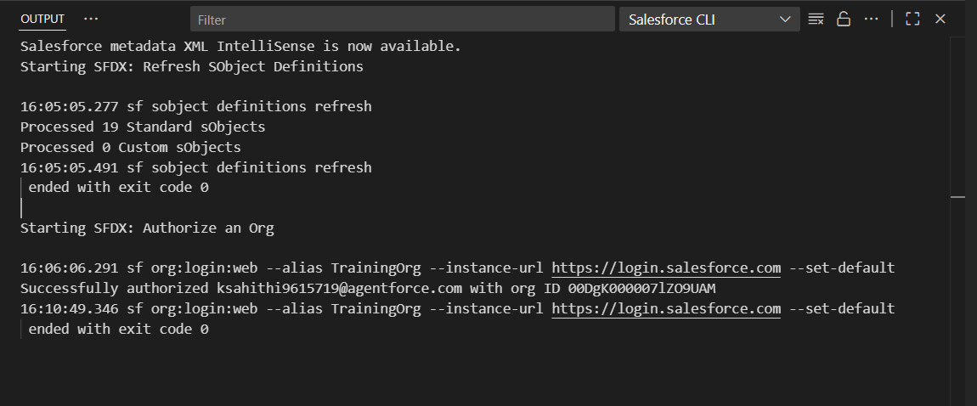

1. **Company Profile Setup**  
   We updated Company Information with details like company name (Learning & Development Org), time zone (IST), currency (INR), and language (English). This ensures the org settings match our training department context.

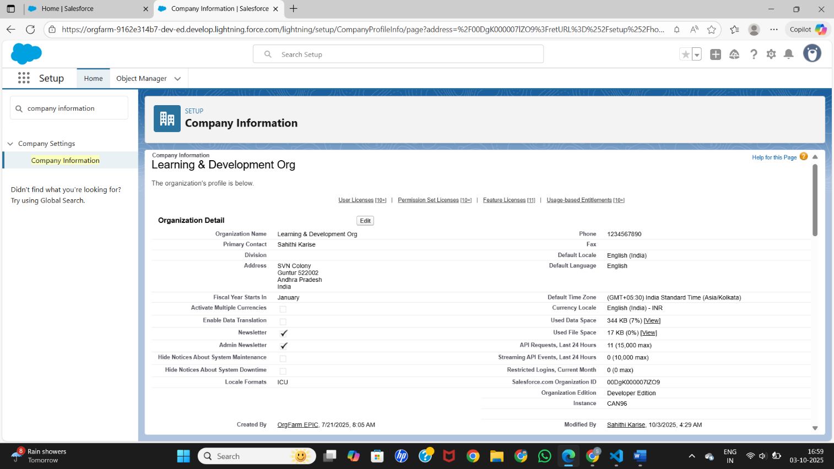

1. **Business Hours & Holidays**  
   We defined Training Department Hours as Monday to Friday (9 AM – 6 PM) with Saturday and Sunday closed. Holidays like Republic Day, Independence Day, and Diwali were added so the system respects non-working days.

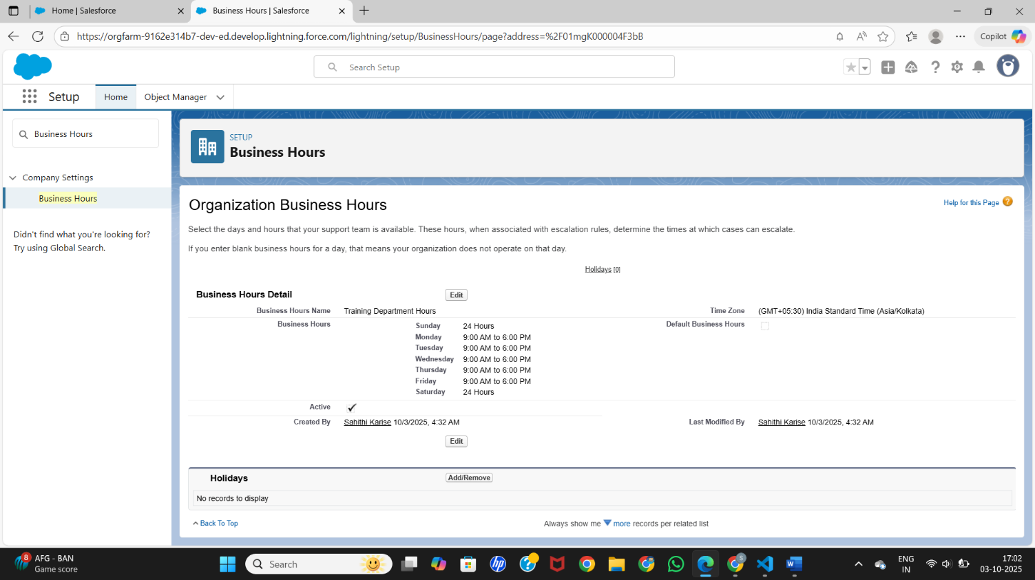

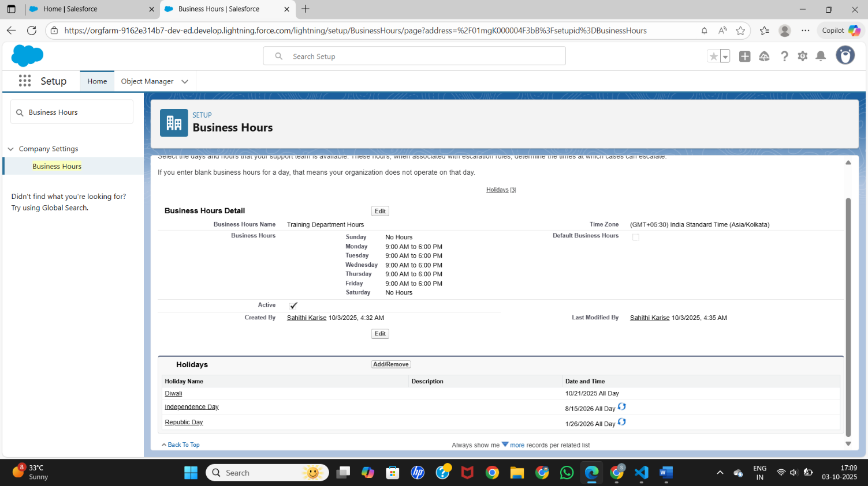

1. **Fiscal Year Settings**  
   We configured a Standard Fiscal Year starting in January. This aligns reporting and analytics with business cycles.

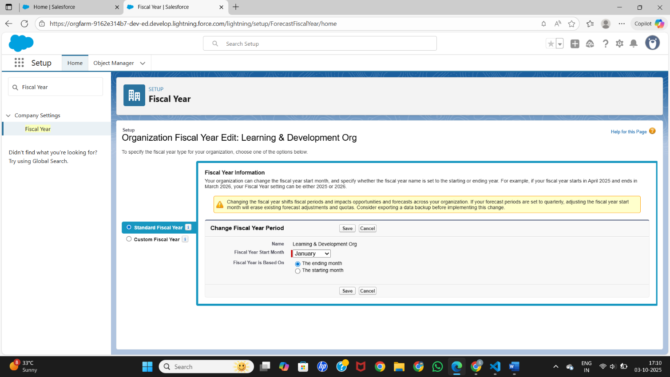

1. **User Setup**  
   We created new users such as Training Coordinator and Instructor in addition to the Admin. Each user was given the Standard User profile for appropriate access.

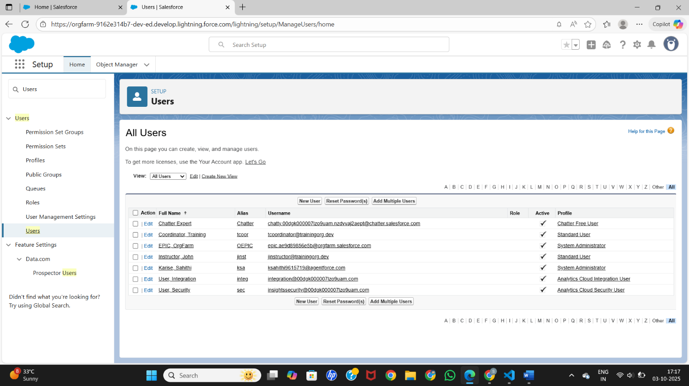

1. **Profiles**  
   We reviewed the Standard User profile to understand the default permissions available to coordinators, instructors, and participants.

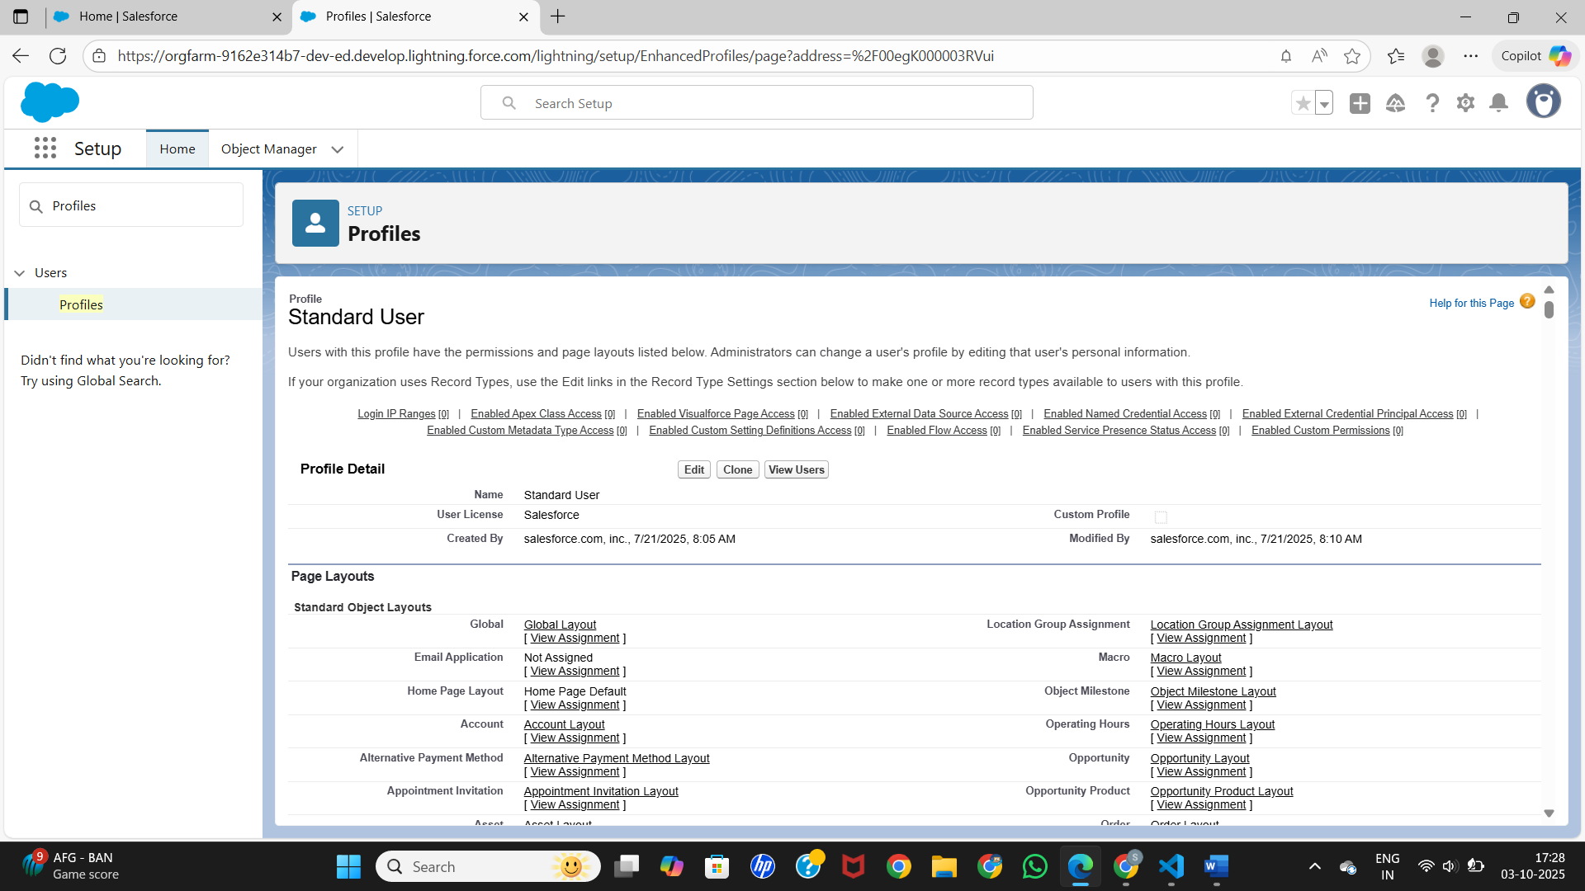

1. **Roles Setup**  
   We created a role hierarchy: CEO at the top, under which we added L&D Manager, and below that Training Coordinator and Instructor. Roles were assigned to users to manage data visibility and approvals.

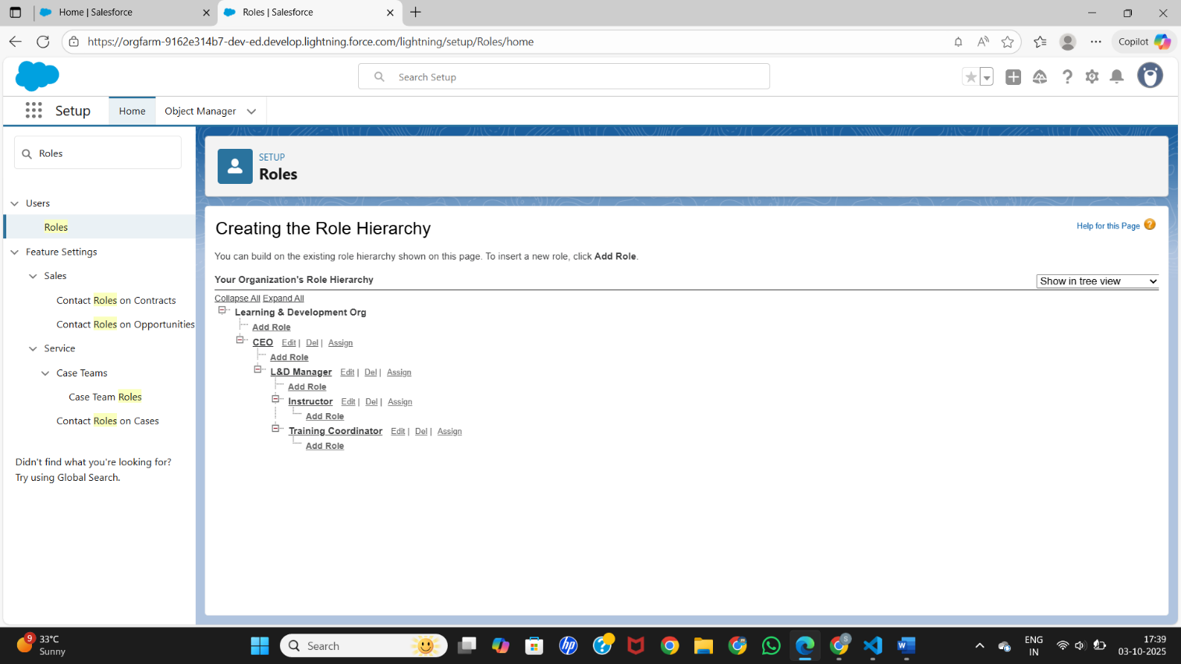

1. **Login Access Policies**  
   We set login hours so users can only log in Monday to Friday (8 AM – 7 PM) and are restricted on weekends. Session settings were updated to a 2-hour timeout.

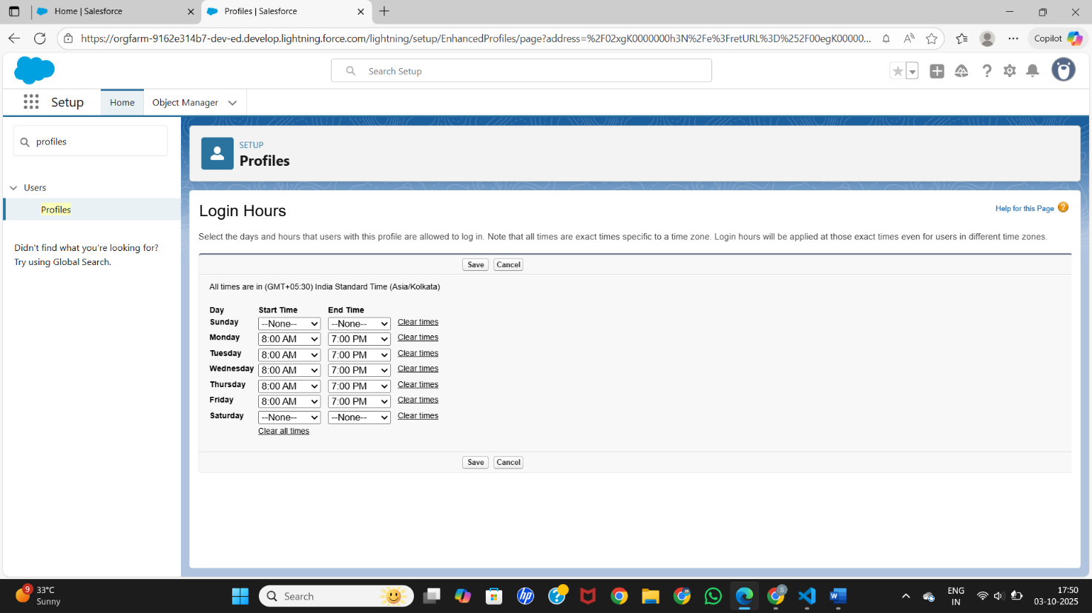

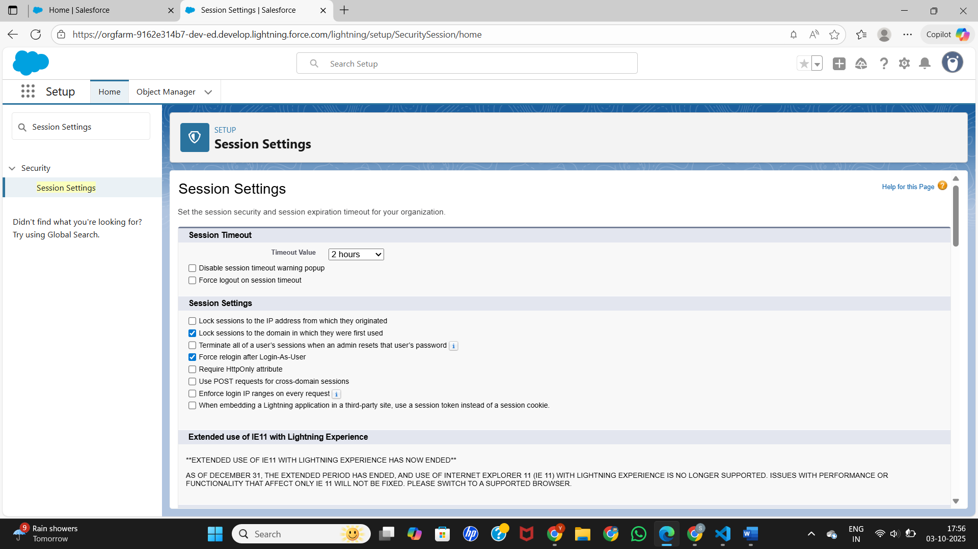

1. **Create Custom App**  
   We built a new Lightning app named Training Management. It includes Home, Reports, and Dashboards tabs. The app was assigned to Admin and Standard User profiles, giving users a dedicated workspace.

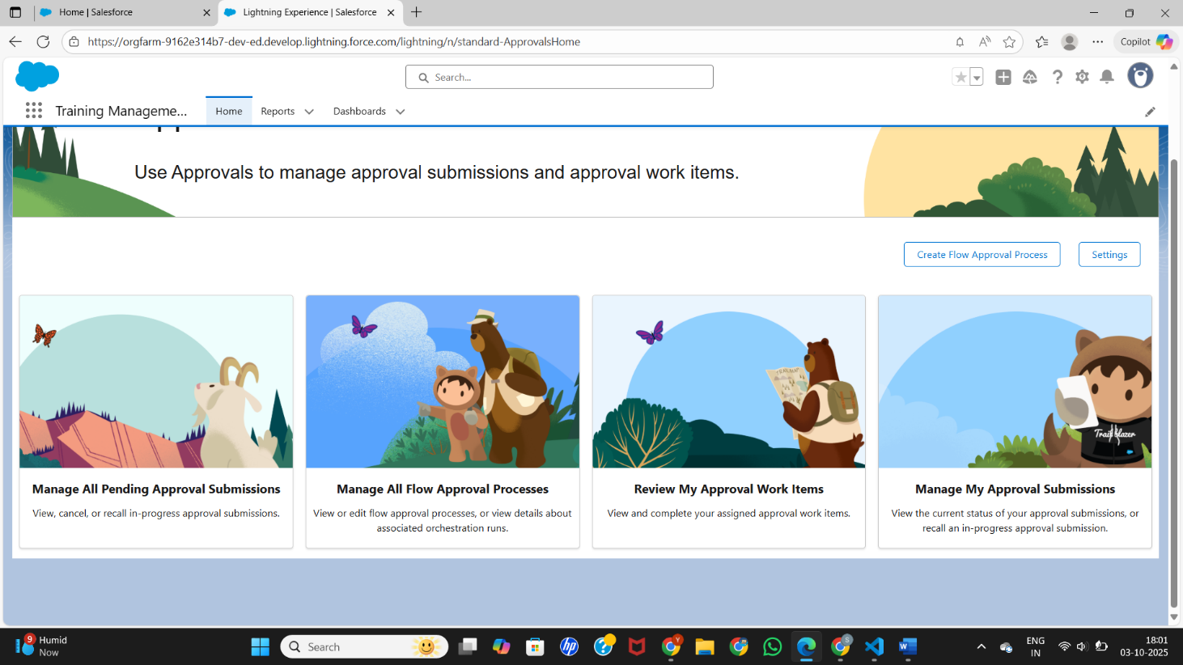

1. **Email Deliverability**  
   We changed the email deliverability setting to All Email. This ensures the system can send notifications, confirmations, and reminders.

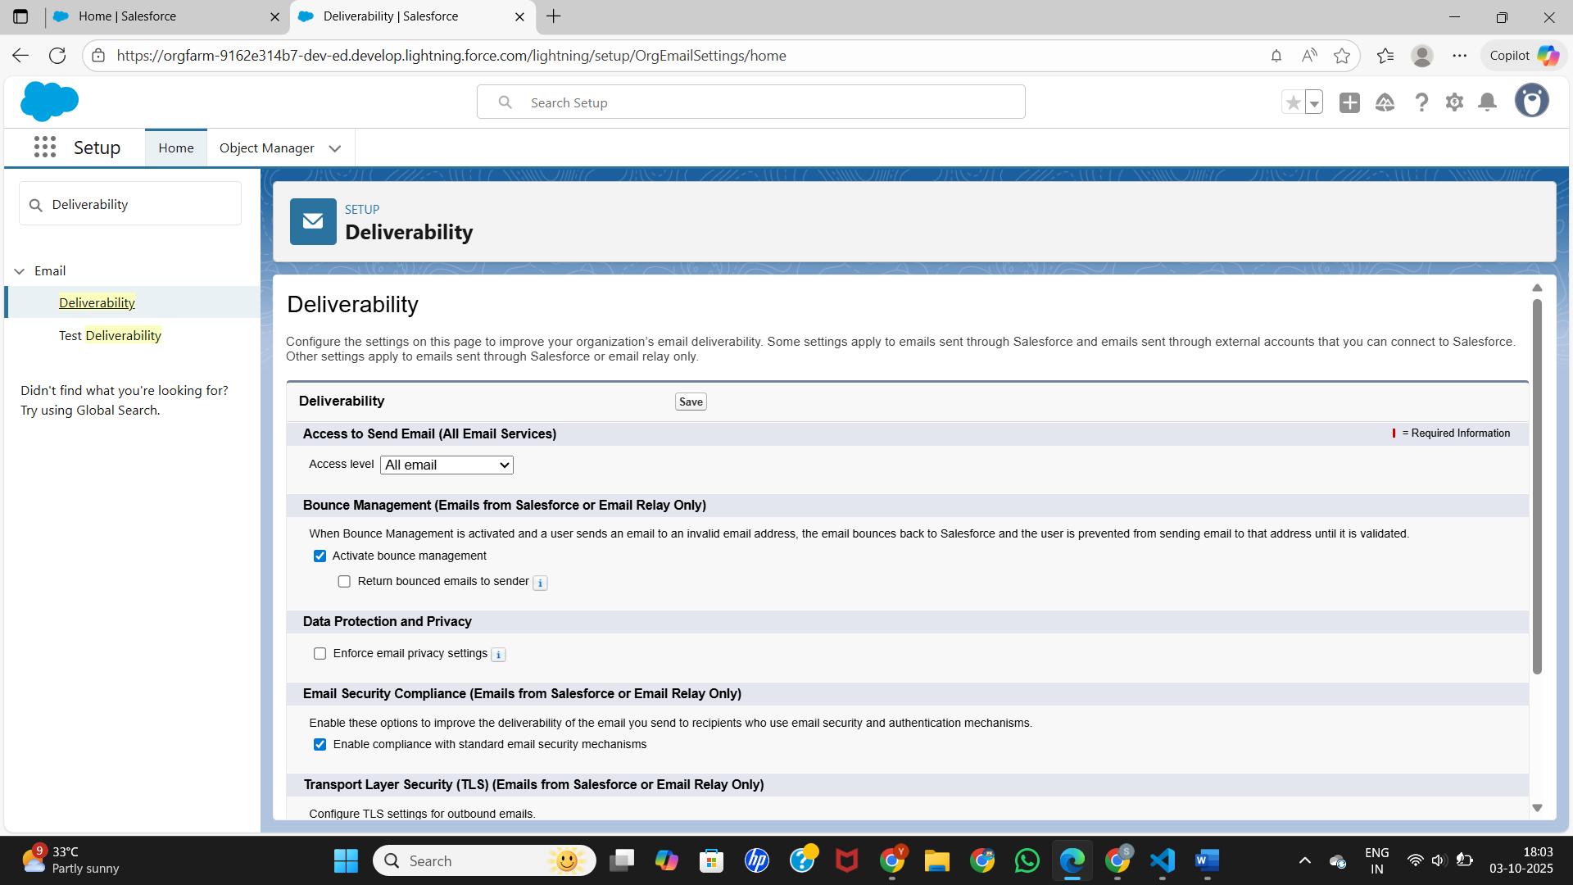

1. **Development Mode**  
   We enabled Development Mode for the org to simplify editing and debugging during development.

